SNAPGRAZE Soil Carbon Dynamic Model Version History
Introduction

SNAPGRAZE is a process-based model of aboveground herbaceous plant production and soil carbon dynamics designed explicitly to incorporate the time and timing of grazing by large mammals and its effect on the growth and regrowth following grazing of herbaceous plants. It was first published as Ritchie (2020) .

SNAPGRAZE Version 1.0. Original version of the model.
The model can be summarized with the following table of parameters, variables and functions
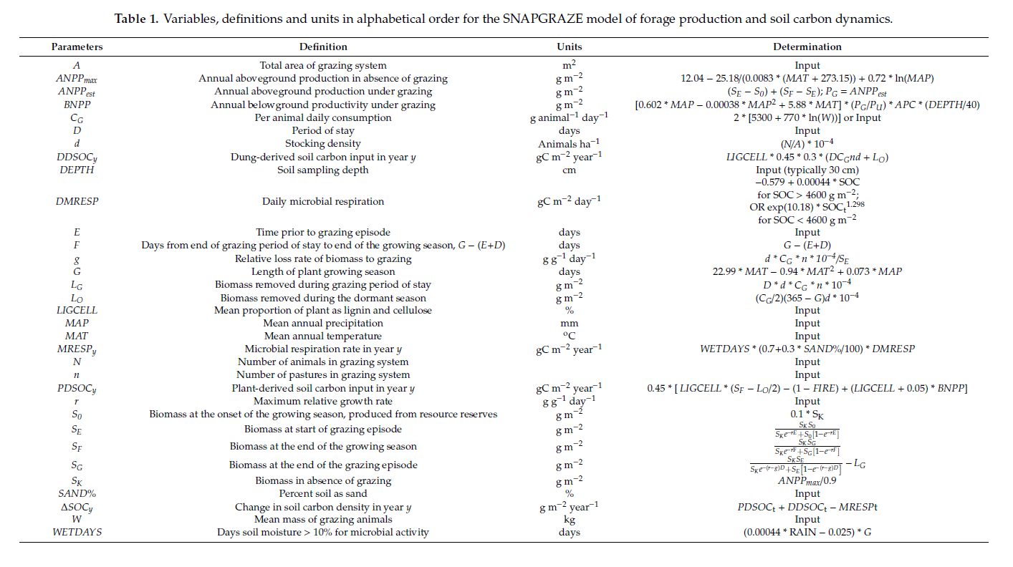
This model constitutes Version 1.0

SNAPGRAZE Version 1.1
This version corrects inconsistencies in the values of some coefficients and exponents. The equation for daily microbial respiration DMRESP at low SOC densities was changed to
DMRESP = exp(-10.872) x SOC^{1.296} (1)
As dictated by the actual regression fit to the data provided in equation (21) of Ritchie(2020)
ln(DMRESP_{y}) = −10.872 +1.296 ln(SOC_{y}) (2)
Further, version 1.1 calculates the plant contribution to SOC as
PDSOC_{y} = 0.45 x [LIGCELL x ANPP^{est}_{y} x (1-FIRE) + (LIGCELL+0.05) x BNPP^{est}_{y}] (3)
Which assumes that all of standing biomass at the end of the growing season potentially decomposed into SOC.
Rather than
PDSOC_{y} = 0.45 x [LIGCELL x (S_{F} – L_{O})/2 x (1-FIRE) + (LIGCELL+0.05) x BNPP^{est}_{y}] (4)
Which assumed that only half of standing biomass at the end of the growing season contributed to SOC, which is likely an underestimate.
Finally, S_{K} = ANPP_{max} rather than ANPP_{max}/0.9, as the division by 0.9 was introduced in the paper as a calibration to local data rather than intended as a universal function. Users may still adjust ANPPmax as a calibration parameter, which is otherwise derived from empirical measurements of ANPP across 40 globally distributed sites.
SNAPGRAZE Version 2.0
This version of SNAPGRAZE recognized that empirical determination of lignin and cellulose values can be difficult in developing countries and that values varied predictably across different plant types. Inputs to SNAPGRAZE were changed for users to enter a dominant plant type: BARE, ANNUALS, MIXTURE, PERENNIALS
Type Label # samples Mean% SD SE
Perennial Grass | PERENNIAL | 9 | 35.676451 | 4.2635418 | 1.4211806
Annual+Forb | ANNUALS or BARE | 38 | 22.719487 | 5.7138914 | 0.9269156
MIXTURE | MIXTURE | 47 | 29.197969 | 4.9887166 | 0.7276791

The raw data used to determine these associations were developed from analysis of plants in East Africa was added to SNAPGRAZE v 2.0 as metadata. Other metadata exist for the northern Great Plains in the USA.

SNAPGRAZE v 2.1 Adding a depth correction
Since different projects sam,ple to different depths, we introduced a function that corrects for depth shallower or deeper than 40 cm (the default depth from the original SNAP model in Serengeti National Park. The data were obtained from the Serengeti based on the paper by McNaughton et al. 1998 in Ecology

Root mass from different depth intervals across a range of mean annual rainfall and soil textures in Serengeti National Park

Depth (cm) | Cumulative root biomass | % of Total
0.1 | 0 | 0 | Mid | Tall | Short
10 | 215 | 0.4201954 | 200 | 265 | 180
20 | 353.3333333 | 0.6905537 | 170 | 95 | 150
30 | 418.3333333 | 0.8175896 | 20 | 50 | 125
40 | 468.3333333 | 0.9153094 | 20 | 30 | 100
50 | 511.6666667 | 1 | 20 | 20 | 90

Analysis of the % of root production at different depths (x) derived from the root production data of McNaughton et al (1998).

This function is used to modify the estimates of plant and dung derived carbon (PDSOC and DDSOC) that when combined with the microbial respiration MRESP determines the magnitude of soil carbon changes

SNAPGRAZE Version 2.2. Modifying Herbivory Functions

In applying the model to herbivore species other than cattle, using the consumption function:
C_{G} = 2*[5300 + 770 ln(W) (5)
Where
C_{G} = daily consumption of plant biomass (g.day⁻¹animal⁻¹)
W = body weight or live mass in kg
Which was originally developed empirically for cattle yielded sometimes infeasible results for smaller herbivores such as sheep or goats.
In version 2.2 the instruction is to convert herbivores into “cattle equivalents,” using published literature for the particular location or breeds involved in the project, such as Ahmed and Mesfin (2017), who used the following table for “Tropical Livestock Units” useful for East Africa originally published by Storck et al in 1991
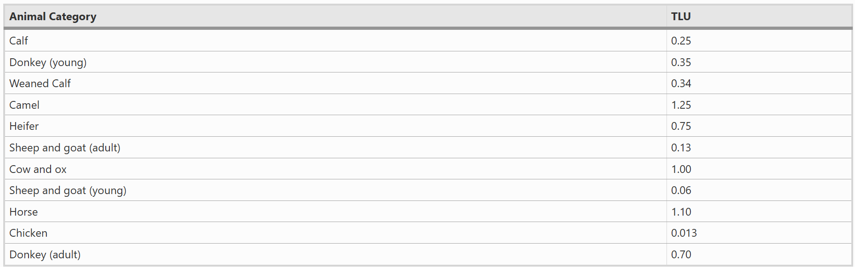
Alternatively, users can use more general equations to estimate active metabolic rates for animals of different body size, such as Nagy’s(1987)measurements of field metabolic rate for different-sized mammals;

derived
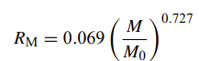 (6)
Where
M = live body mass in kg (equivalent to W in equation (5))
M₀ = standard live body mass (1 kg)
R_{M} = field metabolic rate (watts or joules/sec) for mammals
Calculation of “cattle equivalents” is then given by
$$C_{E}={\left(\frac{M_{i}}{M_{C}}\right)}^{0.727}$$
(7)
Where
C_{E} = Cattle equivalent (dimensionless)
M_{i} = mass in kg of herbivore of interest
M_{C} = mass in kg of average cattle (weighted if possible by ratio of bulls to cows, or median mass of reported mass range) in the project area
Note the coefficient 0.069 and the standard M₀ cancel out in the ratio
The cattle equivalency for each species can then be multiplied by the numbers of individuals of each species to determine the total density of “cattle equivalents” in the project area and then use the mass of cattle in the project area, M_{C} in equation (5)

SNAPGRAZE version 2.3. Modification of dung decomposition
In interviews with dozens of practitioners of various forms of rapid rotational grazing, most declare that formation of bunched herds causes cattle dung to be better incorporated in soil, thus increasing the fraction of dung incorporated as soil organic carbon rather than lost to microbial decomposition of volatilization by UV light.
Previous versions of the equation for DDOC were
Where
LIGCELL = % of plant material as lignin + cellulose
0.45 = proportion of consumed plant material as dung
0.3 = proportion of lignin and cellulose dung not decomposed
D = days in pasture
C_{G} = daily plant biomass consumed (g)
n = number of pastures in grazing system
d = overall density of animals (#/ha)

In version 2.3, the coefficient 0.3 is replaced by a function that increases this proportion inversely with the number of days in pasture D. This assumes that shorter times in pasture are associated with more concentrated herds. Thus the equation, incorporating changes in versions 2.1 and 2.2 becomes
DDOC = LIGCELL x 0.45 x D x C_{G} x n x d x (-0.3914+0.3559 x ln(DEPTH) x (0.4718 – 0.0009 x D)
The added function has not been measured (a research need) but is calibrated to yield a value near 0.3 for season-long grazing in climates with 180-200 growing season days. In cooler climates or rotational systems with lower D and/or lower microbial respiration rates, the function yields a higher incorporation value, up to a maximum value of 0.4718 and a minimum (at 365 days of occupancy) of 0.1433. The lower value agrees with the lower end of published measures of incorporation of 12-26% by either no grazing but bioturbation by earthworms low density livestock operations engaged in continuous grazing over 365 days and without any effect of hoof impacts that would accelerate dung incorporation into soil. The highest value would be associated with operations that move animals in high density herds every day. Unfortunately, measurements of dung incorporation with such extreme management practices have not been made.
The coefficient of 0.3 remains a parameter for calibration, particularly in intensely manged systems with large numbers of pastures receiving dense lkivestock herds, and model users are encouraged to free the parameter for calibration in such instances.

Ritchie, M.E. 2020. Resources 9(4), 49; https://doi.org/10.3390/resources9040049
Ahmed, M.H., Mesfin, H.M. The impact of agricultural cooperatives membership on the wellbeing of smallholder farmers: empirical evidence from eastern Ethiopia. Agric Econ 5, 6 (2017). https://doi.org/10.1186/s40100-017-0075-z; Storck H, Emana B, Adnew B, Borowiccki A, Woldehawariat S (1991) Farming systems and resource economics in the tropics: farming system and farm management practices of smallholders in the Hararghe Highland, vol II. Wissenschaftsverlag Vauk, Kiel
K.A. Nagy. Field metabolic rate and food requirement scaling in mammals and birds. Ecol. Monogr., 57 (1987), pp. 111-128
edhillharvest.com/blog/animals-soil-health-how-livestock-benefit-the-land-help-farms-thrive#:~:text=Manure%20can%20fulfill%20a%20significant,completely%20turn%20our%20farm%20around!
Schon et al. 2014 Quantifying dung carbon incorporation by earthworms in pasture soils European Journal of Soil Science 66: 348-358, https://doi.org/10.1111/ejss.12217;
R. Bol, W. Amelung, C. Friedrich, N. Ostle, 2000. Tracing dung-derived carbon in temperate grassland using 13C natural abundance measurements, Soil Biology and Biochemistry, Volume 32:1337-1343, ISSN 0038-0717, https://doi.org/10.1016/S0038-0717(00)00022-5

